1. Introduction to Power BI Desktop
Power BI Desktop is a Business Intelligence and Data Visualization tool developed by Microsoft. It is used to connect, clean, transform, analyze, and visualize data from different sources.
I downloaded and installed Power BI Desktop on my computer. After installation, I opened the application and created a new blank report.
Power BI Desktop provides different tools and features to create interactive reports and dashboards.
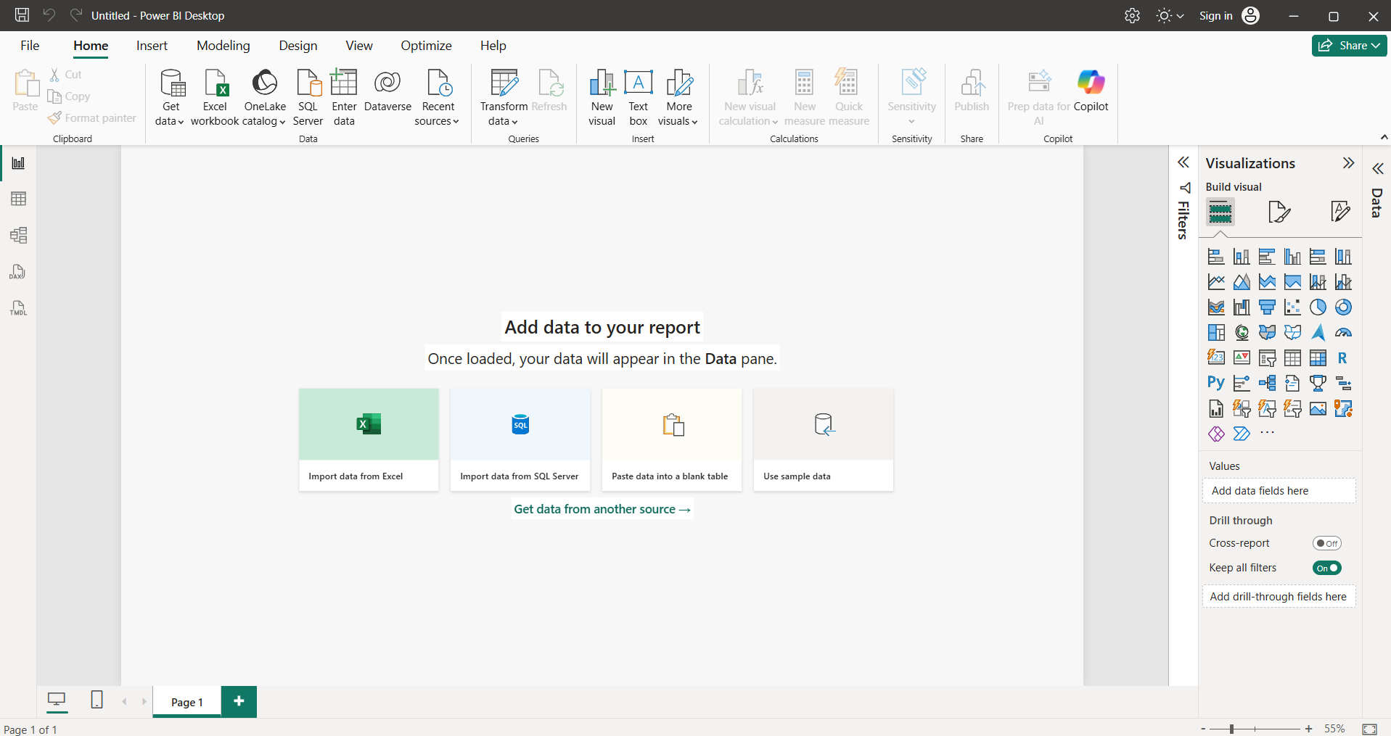

Introduction
Power BI Desktop provides different views and panes that help users manage data, create visualizations, build relationships, and develop interactive reports.

1 Report View
Report View is used to create and design reports using different visualizations such as charts, tables, maps, and cards. It allows users to arrange visuals and create interactive dashboards.

2 Data View
Data View displays the loaded data in rows and columns. It helps users inspect records, check column values, and understand the dataset.

3 Model View
Model View is used to create and manage relationships between different tables. It helps connect tables using common columns and build a proper data model.

4 Fields Pane
The Fields Pane displays all the tables and columns available in the loaded dataset. Users can select or drag and drop fields into visuals to display the required information.

5 Visualizations Pane
The Visualizations Pane provides different types of charts and visual elements, such as bar charts, column charts, pie charts, maps, and tables. It is used to create and format data visualizations.

6 Filters Pane
The Filters Pane is used to filter the data displayed in reports. Users can apply filters to a specific visual, an entire report page, or all report pages.

Conclusion
These components work together to help users manage data, analyze information, create visualizations, and build interactive reports in Power BI Desktop.

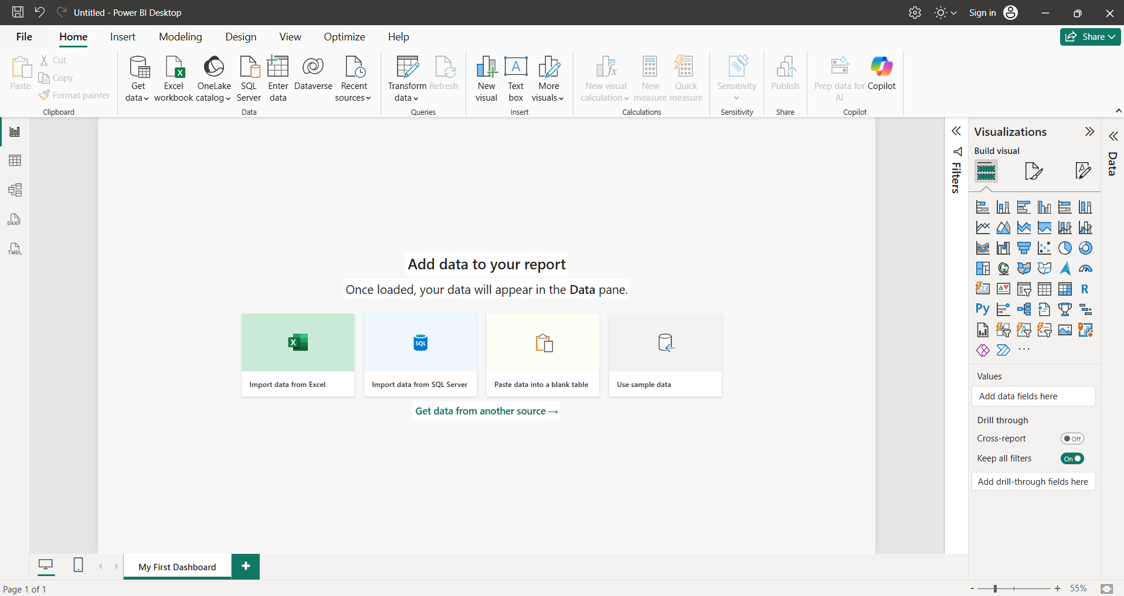

Differences Between Excel Dashboards and Power BI Dashboards

Introduction
Excel and Power BI are both useful tools for data analysis and visualization. However, they have different features and workflows.

1 Data Handling
Excel: Excel uses worksheets, formulas, tables, and PivotTables to manage and analyze data.
Power BI: Power BI uses Power Query to connect, clean, and transform data from multiple sources.

2 Data Visualization
Excel: Excel provides charts, PivotCharts, and slicers to create dashboards.
Power BI: Power BI provides interactive visualizations such as bar charts, maps, cards, treemaps, and slicers.

3 Data Relationships and Sharing
Excel: Excel supports data relationships through the Data Model and allows users to share workbooks.
Power BI: Power BI provides Model View to manage relationships between multiple tables and Power BI Service to publish and share interactive reports.

Comparison Table
Features | Excel Dashboard | Power BI Dashboard
Data Handling | Worksheets, formulas, PivotTables | Power Query and multiple data sources
Visualization | Charts, PivotCharts, slicers | Interactive charts, maps, cards
Relationships & Sharing | Data Model and workbook sharing | Model View and Power BI Service

Conclusion
Excel is useful for spreadsheet-based calculations and analysis, while Power BI is useful for creating interactive reports and visualizing data from multiple sources.

